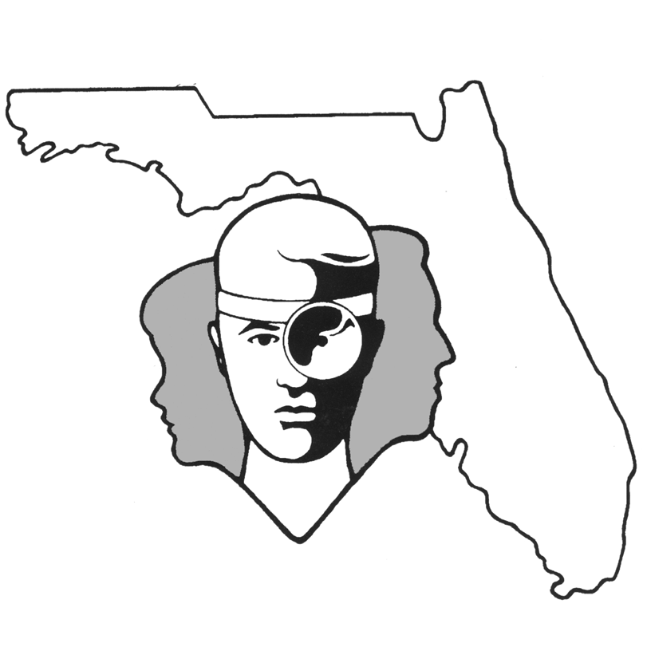

TALLAHASSEE EAR, NOSE & THROAT - HEAD & NECK SURGERY, P.A.

www.TallyENT.com Office Phone: 850-877-0101

PATIENT DISCHARGE INSTRUCTIONS: REPAIR of NASAL FRACTURE

POST-ANESTHETIC CONSIDERATIONS: Anesthetics and other medications will be in your body 24 hours, so you may feel a little sleepy. This feeling will slowly wear off, but for the next 24 hours, adults should not:
- Drive a car, operate machinery or power tools ● Drink any alcoholic beverages
- Take any medication except as directed ● Make any important decisions – such as signing legal documents
Certain anesthetics and pain medications may produce nausea & vomiting which usually resolves by the evening of the surgery.

ACTIVITY: In general, you should avoid any kind of heavy exercise or straining for 2-3 days. After this time, gradually increase exercise. Sleep with your head and shoulders slightly elevated.

DIET: You should progress slowly to a regular diet as tolerated. It is better to start with liquids such as Ginger Ale or apple juice, then soup and crackers, and gradually solid foods.

WOUND CARE: You may take a shower or bath as desired. DO NOT BLOW YOUR NOSE! If you feel like you are going to sneeze, please try to do it with your mouth open. Your nasal splints may loosen as the swelling diminishes. You may gently remove it if this occurs. Leave the tape on your nose. If you have a cast, do your best to keep it dry.

MEDICATIONS: You may have a medication for pain. Be sure to take any medications as prescribed and for the full time recommended by your surgeon. Unless otherwise indicated, you may try taking an antihistamine/decongestant, which might help a little with nasal congestion. Also, at nighttime, to help somewhat with breathing you may try using a topical nasal decongestant (such as Afrin or Duration or any other nose spray or drops). These nasal sprays may be used during the first five days after the procedure. Obviously, in the circumstances of complete nasal packing, this will make no difference. Use only Tylenol or other pain medication prescribed by your surgeon. Do not take aspirin or anti-inflammatory products (Motrin, Advil, Ibuprofen, Aleve, etc.), or any other pain medication other than that prescribed by your surgeon. This is very important as some of these medications can cause bleeding.

SYMPTOMS TO EXPECT: You can expect moderate discomfort the first night. Most patients feel better the second and third days, then slightly worse the fourth day on. You may have some bruising around the eyes. You can expect red (bloody) fluid-type drainage from your nose with some postnasal drainage with this as well. In general, it should gradually decrease over the first couple of days.

WHEN TO CALL YOUR PHYSICIAN:
- If you have brisk bleeding (a fast drip-drip), have purulent (pus-like) drainage, expel clots, and/or
begin to swallow blood
- If you have a temperature of more than 101.5 degrees at any point
- Pain or nausea uncontrolled by the prescribed medications

SPECIAL INSTRUCTIONS: A postoperative appointment has already been scheduled. Please refer to your Surgery Information Sheet or call the office to confirm the appointment date and time. We strongly suggest that a responsible adult be with the surgical patient the rest of the day and also during the night for the surgical patient's protection and safety. Please contact your physician immediately if you have an emergent situation. If you find that you cannot contact them, but feel that your signs and symptoms warrant a physician's attention, go to the nearest emergency room. For non-emergent questions (i.e. appointments or general questions), please call during normal office hours.

